PERMUTATIONS AND COMBINATIONS
PERMUTATIONS |  | CIRCLE PERMUTATIONS |  | PERMUTATIONS WITH REPETITION
$$P\left(n,r\right)=\frac{n!}{\left(n-r\right)!}$$ |  | $$\left(n-1\right)!$$ |  | $$\left({n \atop n_{1}, n_{2},……n_{k}}\right)=\frac{n!}{n_{1}!n_{2}!……n_{k}!}=P(n;n_{1}, n_{2},……n_{k})$$
$$P\left(n,n\right)=P\left(n,n-1\right)=n! \\ P\left(n,1\right)=n$$  $$P\left(n,0\right)=1$$ | Order is important  There is no repetiton |  |  | Order is important  There is repetiton
COMBINATIONS (BINOMIAL COEFFICENT) |  | PACSAL RULE |  | COMBINATIONS WITH REPETITION
$$C\left(n,r\right)=\left({n \atop r}\right)=\frac{n!}{r!\left(n-r\right)!}=\frac{P\left(n,r\right)}{r!}$$ |  | $$\left({n+1 \atop r}\right)=\left({n \atop r-1}\right)+\left({n \atop r}\right)$$ |  | $$\left({n+k-1 \atop k}\right)=\left({n+k-1 \atop n-1}\right)$$
$$C\left(n,n\right)=C\left(n,0\right)=C\left(0,0\right)=1$$  $$C\left(n,1\right)=n$$  $$C\left(n,r\right)=C\left(n,n-r\right)$$  $$C\left(n,r\right)=0, for r>n or r<0$$ | Order is not important  There is no repetiton  $$\left({-r \atop k}\right)={\left(-1\right)}^{k}\left({r+k-1 \atop k}\right)$$ |  |  | Order is not important  There is repetiton
BINOMIAL EXPANSION |  |  | BINOMIAL EXPANSION
$${\left(a+b\right)}^{n}=\sum_{r=0}^{n}{\left({n \atop r}\right)a^{n-r}b^{r}}=\left({n \atop 0}\right)a^{n}b^{0}+\left({n \atop 1}\right)a^{n-1}b^{1}+…+\left({n \atop n}\right)a^{0}b^{n}=a^{n}+na^{n-1}b+\frac{n(n-1)}{1.2}a^{n-2}b^{2}…nab^{n-1}+b^{n}$$ |  |  | $${\left(x_{1}+x_{1}+…+x_{k}\right)}^{n}=\sum_{n_{1}, n_{2},……n_{k}}^{n}{\left({n \atop n_{1}, n_{2},……n_{k}}\right){x_{1}}^{n_{1}}{x_{2}}^{n_{2}}……{x_{k}}^{n_{k}}}, n=n_{1}+n_{1}+…+n_{k}$$
 |  |  | $$Number of terms=\left({n+k-1 \atop n}\right)$$

MARKOV INEQUALITY | CHEBYSHEV INEQUALITY |  |  | DIRAC DELTA FUNCTION and UNIT STEP FUNCTION
$$P\left(X≥c\right)≤\frac{E(X)}{c}$$ | $$P\left(\left|X-μ\right|<kσ\right)≥1-\frac{1}{k^{2}}$$ | $$P\left(\left|X-μ\right|≥kσ\right)≥\frac{1}{k^{2}}$$ | $$P\left(\left|X-μ\right|≥k\right)≥\frac{σ^{2}}{k^{2}}$$ | $$δ\left(x-x_{0}\right)=\left\{\begin{aligned}∞, x=x_{0} \\ 0, x≠x_{0}\end{aligned}\right.$$ | $$δ\left(x-x_{0}\right)=\frac{d}{dx}u\left(x-x_{0}\right)$$ | $$u\left(x-x_{0}\right)=\left\{\begin{aligned}1, if x≥x_{0} \\ 0, if x<x_{0}\end{aligned}\right.$$
 |  |  |  | $$\int_{x_{0}-ε}^{x_{0}+ε}{δ\left(x-x_{0}\right)dx}=1$$ | $$\int_{x_{0}-ε}^{x_{0}+ε}{g(x)} δ\left(x-x_{0}\right)dx=\int_{-∞}^{∞}{g(x)} δ\left(x-x_{0}\right)dx=g(x_{0})$$

PROBABILITY
CONVENTIONAL DEFINITION | FREQUENCY DEFINITION | SUBJECTIVE DEFINITION
$$p\left(A\right)=\frac{n(A)}{n(S)}$$ | $$p\left(A\right)=\lim_{N→∞}{\frac{n}{N}}$$ | $$\frac{p\left(A\right)}{1-p\left(A\right)}=\frac{x}{y} ⟹ p\left(A\right)=\frac{x}{x+y}$$
PROBABILITY OF UNION |  | BOOLE INEQUALITY | BONFERONI INEQUALITY
$$P\left(A_{1}∪A_{2}∪…∪A_{n}\right)=\sum_{i=1}^{n}{P\left(A_{i}\right)}-\sum_{1≤i<j≤n}{P\left(A_{i}∩A_{j}\right)}+\sum_{1≤i<j<k≤n}{P\left(A_{i}∩A_{j}∩A_{k}\right)}-…+{\left(-1\right)}^{n-1}P\left(A_{1}∩A_{2}∩…∩A_{n}\right)$$ |  | $$P\left(A_{1}∪A_{2}\right)≤P\left(A_{1}\right)+P\left(A_{2}\right)$$ | $$P\left(A_{1}∩A_{2}\right)≥P\left(A_{1}\right)+P\left(A_{2}\right)-1$$
 |  | $$P\left(\bigcup_{İ=1}^{n}{A_{i}}\right)≤\sum_{i=1}^{n}{P\left(A_{i}\right)}$$ | $$P\left(\bigcap_{İ=1}^{n}{A_{i}}\right)≥\sum_{i=1}^{n}{P\left(A_{i}\right)}-1$$
CONDITIONAL PROBABILITY | DISJOINT EVENTS | INDEPENDENT EVENTS | BAYES’ THEOREM
$$P\left(\left.A\right|B\right)=\frac{P(A∩B)}{P(B)}, P(B)>0$$ | $$\sum_{i=1}^{n}{P(B_{i})}=1$$ | $$A and B are independent if and only if; \\ P\left(\left.A\right|B\right)=P\left(A\right) or P\left(\left.B\right|A\right)=P\left(B\right)$$ | 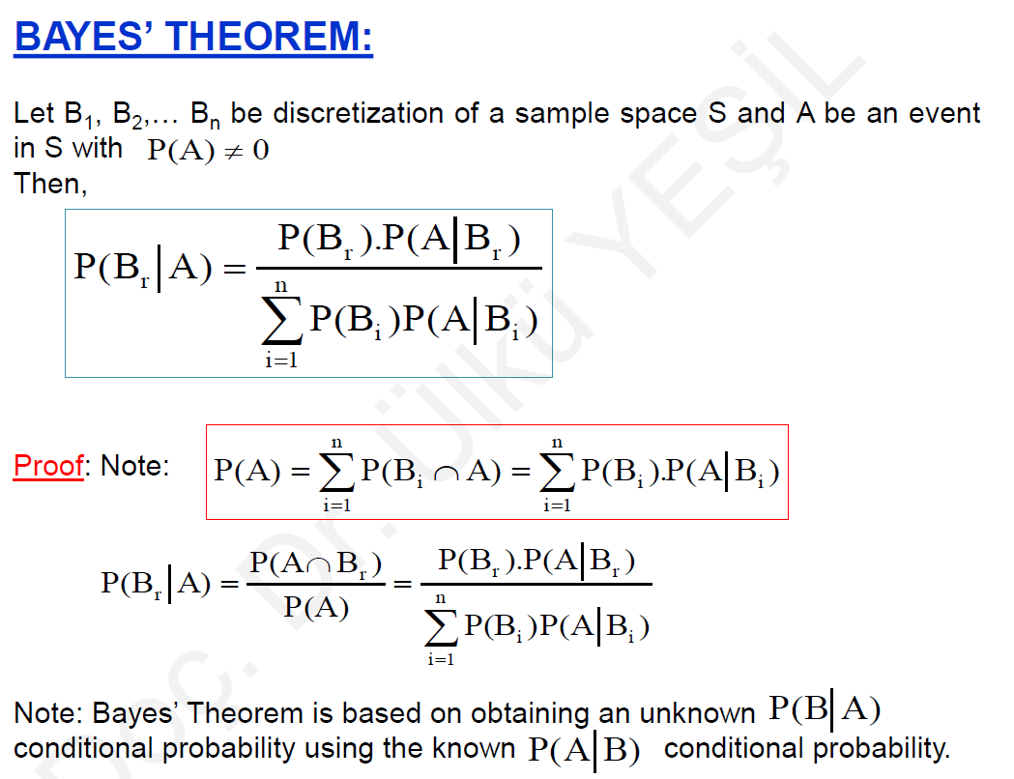
$$P\left(\left.A\right|A\right)=1$$  $$P\left(A_{1}∩A_{2}\right)=P\left(\left.A_{1}\right|A_{2}\right)∙P\left(A_{2}\right)=P\left(\left.A_{2}\right|A_{1}\right)∙P\left(A_{1}\right)$$  $$P\left(\bigcap_{İ=1}^{n}{A_{i}}\right)= P\left(A_{1}\right)∙ P\left(\left.A_{2}\right|A_{1}\right)∙ P\left(\left.A_{3}\right|A_{1}A_{1}∩A_{2}\right)∙…∙P\left(\left.A_{n}\right|\left(\bigcap_{İ=1}^{n-1}{A_{i}}\right)\right)$$ | $$P\left(A\right)=\sum_{i=1}^{n}{P(B_{i}∩A)}=\sum_{i=1}^{n}{P(B_{i})P(\left.A\right|B_{i})}$$ | $$P\left(A∩B\right)=P(A)∙P(B)$$  $$P\left(\bigcap_{İ=1}^{n}{A_{i}}\right)=\prod_{i=2}^{n}{P\left(A_{i}\right)}$$

DISCRETE RANDOM VARIABLES
PROBABILITY FUNCTIONS (PROBABILITY DISTRIBUTION) | CUMULATIVE DISTRIBUTION FUNCTION | EXPECTED VALUE
$$f\left(x_{i}\right)=P(X=x_{i})$$ | $$F\left(x\right)=\sum_{u≤x}{f\left(u\right)} for-∞<x<∞$$ | $$E\left(x\right)=μ_{x}=\sum_{i=1}^{n}{x_{i}f(x_{i})}$$
$$\sum_{x}{f\left(x_{i}\right)}=1$$ | $$P\left(X>a\right)=1-P\left(X≤a\right)=1-F(a)$$  $$P\left(a<X≤b\right)=F\left(b\right)-F(a)$$ | $$E\left(g\left(x\right)\right)=μ_{g(x)}=\sum_{i=1}^{n}{g\left(x_{i}\right)f\left(x_{i}\right)}$$
VARIANCE AND STANDARD DEVIATION | MOMENT | MOMENT GENERATION FUNCTION
$$V\left(X\right)=Var\left(X\right)=σ_{X}^{2}=E\left[{\left(X-μ\right)}^{2}\right]=\sum_{x}{{\left(X-μ\right)}^{2}f\left(x\right)}$$ | $$m_{r}=E\left[{\left(X\right)}^{r}\right]=\sum_{i=1}^{n}{{\left(x_{i}\right)}^{r}f(x_{i})}$$ | $$M_{x}\left(t\right)=E\left[e^{tX}\right]=\sum_{i=1}^{k}{e^{x_{i}t}.f(x_{i})}$$
 | $$μ_{r}=E\left[{\left(X-a\right)}^{r}\right]=\sum_{i=1}^{n}{{\left(x_{i}-a\right)}^{r}f(x_{i})}$$ | $$M_{x}\left(t\right)=1+tm_{1}+\frac{t^{2}}{2!}m_{2}+\frac{t^{3}}{3!}m_{3}+…+\frac{t^{r}}{r!}m_{r}+…$$

CONTINUOUS RANDOM VARIABLES
PROBABILITY FUNCTIONS |  | CUMULATIVE DISTRIBUTION FUNCTION |  | EXPECTED VALUE
$$f\left(x\right)≥0, P\left(a≤X≤b\right)=\int_{a}^{b}{f\left(x\right)dx}$$ |  | $$F\left(x\right)=P\left(X≤x\right)=\int_{-∞}^{x}{f(u)}du for-∞<x<∞$$ |  | $$E\left(x\right)=μ_{x}=$$
$$\int_{-∞}^{∞}{f(x)}dx=1$$ | $$P\left(X=a\right)=0$$ | $$\lim_{x→-∞}{F\left(x\right)}=F\left(-∞\right)=0$$  $$\lim_{x→∞}{F(x)}=F\left(∞\right)=1$$ | $$F'\left(x\right)=f(x)$$  $$P\left(X>a\right)=1-F(a)$$  $$P\left(a<X≤b\right)=F\left(b\right)-F(a)$$ | $$E\left(g\left(x\right)\right)=μ_{g(x)}=\int_{-∞}^{∞}{g(x)f(x)}dx$$
$$P\left(a<X<b\right)=P\left(a≤X<b\right)=P\left(a<X≤b\right)=P\left(a≤X≤b\right)$$
VARİANCE AND STANDARD DEVIATION |  | MOMENT |  | MOMENT GENERATION FUNCTION
$$V\left(X\right)=Var\left(X\right)=σ_{X}^{2}=E\left[{\left(X-μ\right)}^{2}\right]=\int_{-∞}^{∞}{{\left(X-μ\right)}^{2}f\left(x\right)dx}$$ |  | $$m_{r}=E\left[{\left(X\right)}^{r}\right]=\int_{-∞}^{∞}{{\left(x\right)}^{r}f(x)}dx$$ |  | $$M_{x}\left(t\right)=E\left[e^{tX}\right]=\int_{-∞}^{∞}{e^{xt}.f\left(x\right)dx}$$
 |  | $$μ_{r}=E\left[{\left(X-a\right)}^{r}\right]=\int_{-∞}^{∞}{{\left(x-a\right)}^{r}f(x)}dx$$

MIXED RANDOM VARIABLES
GENERALIZED PROBABILITY FUNCTIONS |  | CUMULATIVE DISTRIBUTION FUNCTION |  | EXPECTED VALUE
$$f_{G}\left(x\right)=\frac{dF(x)}{dx}=\sum_{i=1}^{k}{f\left(x_{i}\right)δ(x-x_{i})}$$ |  | $$F\left(x\right)=\sum_{i=1}^{k}{f\left(x_{i}\right)u(x-x_{i})}$$ |  | $$E\left(x\right)=μ_{x}=\sum_{i=1}^{n}{x_{i}f(x_{i})}+\int_{-∞}^{∞}{xg(x)}dx$$
$$\sum_{x}{f\left(x_{i}\right)}=1$$ | $$\int_{-∞}^{∞}{f_{G}\left(x\right)dx}=1$$ |  |  | $$E\left(g\left(x\right)\right)=\sum_{i=1}^{n}{g\left(x_{i}\right)f\left(x_{i}\right)}$$
VARIANCE AND STANDARD DEVIATION
$$Var\left(X\right)=\int_{-∞}^{∞}{{\left(x-μ_{x}\right)}^{2}f_{G}\left(x\right)dx}=\sum_{i=1}^{n}{{\left(x_{i}-μ_{x}\right)}^{2}f\left(x_{i}\right)+\int_{-∞}^{∞}{{\left(x-μ_{x}\right)}^{2}f(x)}dx}$$

PROPERTIES OF EXPECTED VALUE | PROPERTIES OF VARIANCE |  | PROPERTIES OF MOMENT | PROPERTIES OF MOMENT GENERATION FUNCTION
- $E\left(c\right)=c$  - $E\left(X+c\right)=c$  - $E\left(cX\right)=cE\left(X\right)$  - $x≥0 ⟹ E\left(X\right)≥c$  - $x≤y ⟹ E\left(X\right)≤E\left(Y\right)$  - $E\left(X+Y\right)=E\left(X\right)+E\left(Y\right)$  - $\left|E\left(X\right)\right|≤E\left(\left|X\right|\right)$  - $X and Y are independent ⟹ E\left(XY\right)=E\left(X\right)E\left(Y\right)$  - $E\left(X^{2}\right)≠{\left[E\left(X\right)\right]}^{2}$  - $E\left(aX+b\right)=aE\left(X\right)+b$ | - $Var\left(X\right)=E\left(x^{2}\right)-{\left[E\left(x\right)\right]}^{2}$  - $Var\left(c\right)=0$  - $Var\left(X+c\right)=Var\left(X\right)$  - $Var\left(cX\right)=c^{2}Var\left(X\right)$  - $Var\left(aX+b\right)=a^{2}Var\left(X\right)$  - $σ_{X}=\sqrt{Var(X)}$ |  | - $m_{O}=1$  - $m_{1}=E\left(x\right)=μ$  - $If a=μ then;$$$μ_{2}=E\left[{\left(X-μ\right)}^{2}\right]=Var\left(X\right) \\ μ_{1}=0 \\ μ_{2}=m_{2}-{m_{1}}^{2} \\ μ_{3}=m_{3}-3m_{1}m_{2}+2{m_{1}}^{3}$$ | - $M_{x}^{'}\left(t=0\right)=m_{1}=E\left(x\right)=μ$  - $M_{x}^{''}\left(t=0\right)=E\left(X^{2}\right)$  - $M_{x}^{(n)}\left(t=0\right)=E\left(X^{n}\right)$  - $Var\left(X\right)=E\left(x^{2}\right)-{\left[E\left(x\right)\right]}^{2}$=$M_{x}^{''}\left(0\right)-{\left[M_{x}^{'}\left(0\right)\right]}^{2}$  - $M_{X+a}\left(t\right)=E\left[e^{\left(X+a\right)t}\right]=e^{at}M_{X}\left(t\right)$  - $M_{bX}\left(t\right)=E\left[e^{\left(bX\right)t}\right]=M_{X}\left(bt\right)$  - $M_{Y}\left(t\right)=M_{aX+b}\left(t\right)=e^{bt}M_{X}\left(at\right)$  - $M_{\frac{X+a}{b}}\left(t\right)=e^{\frac{a}{b}t}M_{X}\left(\frac{t}{b}\right)$
PROPERTIES OF COVARIANCE |  | PROPERTIES OF CORRELATION |  |  | PROPERTIES OF JOINT EXPECTED VALUE
- $Cov\left(X,Y\right)=E\left(X-E\left(X\right)\right) E\left(Y-E\left(Y\right)\right)=E\left(XY\right)-E\left(X\right)E\left(Y\right)=E\left(XY\right)-μ_{X}μ_{Y}$  - $Cov\left(X,Y\right)=Cov\left(Y,X\right)$  - $Cov\left(X,X\right)=Var\left(X\right)={σ_{X}}^{2}$  - $If X and Y are independent$ $⟹ {μ_{1,1}}^{'}-μ_{X}μ_{Y}=E\left(X\right)E\left(Y\right)-E\left(X\right)E\left(Y\right)=0$  - $Var\left(X±Y\right)=Var\left(X\right)+Var\left(Y\right)±2Cov(X,Y)$ |  | - $-1≤ρ_{XY}≤1$  - $No lineer correlation: ρ_{XY}=0$  - $Inverse linear correlation: ρ_{XY}<0$  - $Linear correlation: ρ_{XY}>0$  - $Perfect inverse linear correlation: ρ_{XY}=-1$  - $Perfect linear correlation:ρ_{XY}=1$  - $ρ_{XY}=ρ_{YX}$ |  |  | 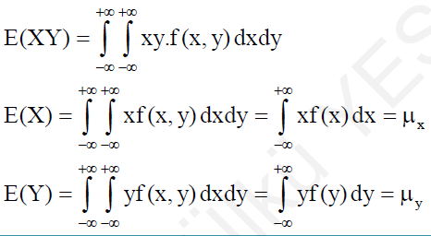

JOINT DISCRETE (DISTRIBUTION) MULTIVARIABLES
JOINT PROBABILITY DISTRIBUTION |  | JOINT (CUMULATIVE) DISTRIBUTION FUNCTION |  |  |  | MARGINAL DISTRIBUTION
$$f\left(x,y\right)=P(X=x,Y=y)$$ |  | $$F\left(x,y\right)=P\left(X≤x,Y≤y\right)=\sum_{s≤x}{\sum_{t≤y}{f(s,t)}}$$ |  |  |  | $$g\left(x\right)=\sum_{y}{f(x,y)}$$ |  |  | $$h\left(y\right)=\sum_{x}{f(x,y)}$$
$$\sum_{x}{\sum_{y}{f\left(x,y\right)=1}}$$ |  | $$F\left(X_{1},X_{2},…,X_{n}\right)=P(X_{1}≤x_{1},X_{2}≤x_{2},…,X_{n}≤x_{n})$$
$$f\left(X_{1},X_{2},…,X_{n}\right)=P(X_{1}=x_{1},X_{2}=x_{2},…,X_{n}=x_{n})$$
CONDITINAL DISTRIBUTION |  | INDEPENDENCE |  |  |  | EXPECTED VALUE
 |  | 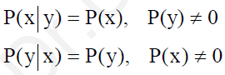 |  | 
 |  | 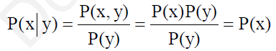 |  |  |  | CONDITIONAL EXPECTATION
 |  |  |  |  |  | 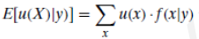
 |  | COVARIANCE
 |  |  |  |  |  | MOMENTS OF LINEAR COMBINATIONS
 |  | $$σ_{XY}=Cov\left(X,Y\right)=C\left(X,Y\right)={μ_{1,1}}^{'}-μ_{X}μ_{Y}$$
 |  |  |  |  |  | $$If Y=Y_{1}=\sum_{i=1}^{n}{a_{i}X_{i}} and Y_{2}=\sum_{i=1}^{n}{b_{i}X_{i}}, then;$$
CORRELATION |  | PRODUCT MOMENTS
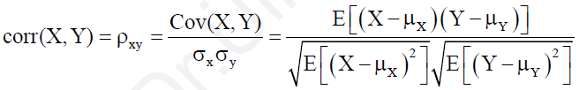 |  | 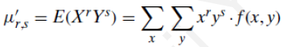
$$If Y=aX+b then;$$  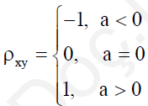 |  |  |  |  |  | $$If X_{1},X_{2},…,X_{n} are independent, then; Var\left(Y\right)=\sum_{i=1}^{n}{{a_{i}}^{2}Var(X_{i})}$$
 |  |  |  |  |  | $$If X_{1},X_{2},…,X_{n} are independent, then; Var\left(Y_{1},Y_{2}\right)=\sum_{i=1}^{n}{a_{i}b_{i}Var(X_{i})}$$
JOINT CONTINUOUS (DENSITY) MULTIVARIABLES
JOINT PROBABILITY DENSITY FUNCTIONS (PDF) |  | JOINT DISTRIBUTION FUNCTION |  |  |  |  | MARGINAL DENSITY
$$P\left[\left(X,Y\right)∈A\right]=P(a<X<b, c<Y<d)=\iint_{A}^{ }{f(x,y)dxdy}$$ |  | $$F\left(x,y\right)=P\left(X≤x,Y≤y\right)=\int_{-∞}^{y}{\int_{-∞}^{x}{f(s,t)dsdt}}$$ |  |  |  |  | $$g\left(x\right)=\int_{-∞}^{∞}{f(x,y)dy}$$ |  | $$h\left(y\right)=\int_{-∞}^{∞}{f(x,y)}dx$$
$$\int_{-∞}^{∞}{\int_{-∞}^{∞}{f\left(x,y\right)dxdy=1}}$$ |  | $$f\left(x,y\right)=F_{xy}(x,y)$$ | $$F_{x}\left(x,y\right)=\int_{-∞}^{y}{f(x,t)∂t}$$ |  | $$F_{y}\left(x,y\right)=\int_{-∞}^{y}{f(s,t)∂s}$$
$$f\left(x_{1},x_{2},…,x_{n}\right)=\frac{∂^{n}}{∂x_{1}∂x_{2}…∂x_{n}} F\left(x_{1},x_{2},…,x_{n}\right)$$ |  | $$F\left(X_{1},X_{2},…,X_{n}\right)=\int_{-∞}^{x_{n}}{…}\int_{-∞}^{x_{2}}{ \int_{-∞}^{x_{1}}{f\left(t_{1},t_{2},…,t_{n}\right){dt}_{1}dt_{2}…dt_{n}}}$$
CONDITINAL DENSITY |  | INDEPENDENCE |  |  |  | EXPECTED VALUE
 |  |  |  | 
 |  |  |  |  |  | CONDITIONAL EXPECTATION
 |  |  |  |  |  | 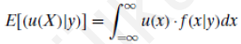
 |  | COVARIANCE
 |  |  |  |  |  | MOMENTS OF LINEAR COMBINATIONS
 |  | $$σ_{XY}=Cov\left(X,Y\right)=C\left(X,Y\right)={μ_{1,1}}^{'}-μ_{X}μ_{Y}$$
 |  |  |  |  |  | $$If Y=Y_{1}=\sum_{i=1}^{n}{a_{i}X_{i}} and Y_{2}=\sum_{i=1}^{n}{b_{i}X_{i}}, then;$$
CORRELATION |  | PRODUCT MOMENTS
 |  | 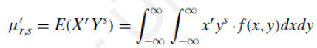
$$If Y=aX+b then;$$   |  |  |  |  |  | $$If X_{1},X_{2},…,X_{n} are independent, then; Var\left(Y\right)=\sum_{i=1}^{n}{{a_{i}}^{2}Var(X_{i})}$$
 |  |  |  |  |  | $$If X_{1},X_{2},…,X_{n} are independent, then; Var\left(Y_{1},Y_{2}\right)=\sum_{i=1}^{n}{a_{i}b_{i}Var(X_{i})}$$

SPECIAL PROBABLITY DISTRIBUTIONS
DISCRETE UNIFORM DISTRIBUTION |  |  | VARIANCE
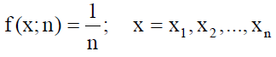 |  |  | 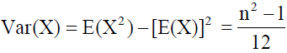
EXPECTED VALUE
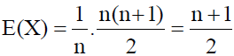 |  |  | 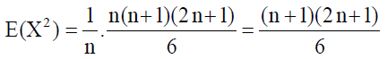
CONTINUOUS UNIFORM DISTRIBUTION |  |  | CUMULATIVE PROBABILITY FUNCTION
THE BERNOULLI DISTRIBUTION |  |  |  | BERNOULLI EXPECTED VALUE
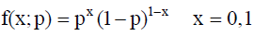 | $p+q=1;$ 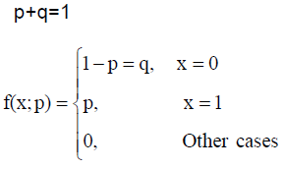 | 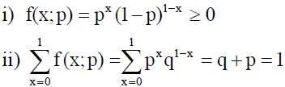 |  | 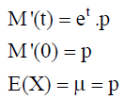 |  | 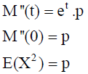
BERNOULLI MOMENT GENERATING FUNCTION |  |  |  | BERNOULLI VARIANCE
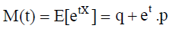 |  |  |  | 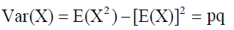

BINOMIAL DISTRIBUTION |  |  |  | BINOMIAL EXPECTED VALUE
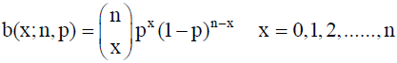 |  | 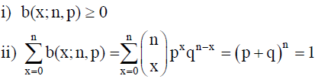 |  | 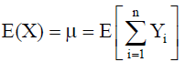  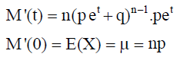 | 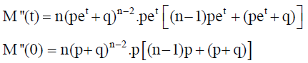  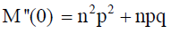  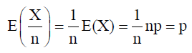
BINOMIAL MOMENT GENERATING FUNCTION |  |  |  | BINOMIAL VARIANCE
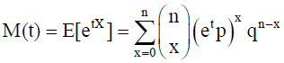 | 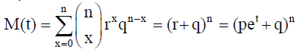 |  |  | 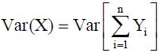 |  | 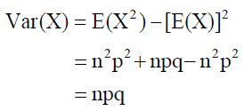
 |  |  |  | 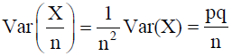
MULTINOMIAL DISTRIBUTION |  |  | MULTINOMIAL EXPECTED VALUE
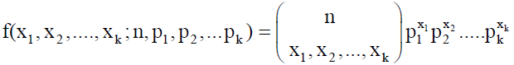 |  |  | 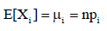
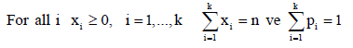
 |  |  | MULTINOMIAL VARIANCE
 |  |  | 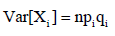

GEOMETRIC DISTRIBUTION |  |  |  | GEOMETRIC EXPECTED VALUE
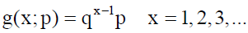 |  |  |  | 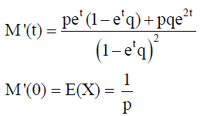 |  |  | 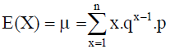  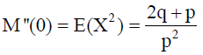
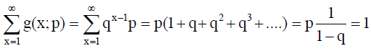
GEOMETRIC MOMENT GENERATING FUNCTION |  |  |  | GEOMETRIC VARIANCE
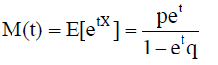 |  |  |  | 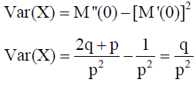 |  |  |  | 
EGATIVE BINOMIAL (PASCAL) DISTRIBUTION |  |  |  |  |  | NEGATIVE BINOMIAL EXPECTED VALUE
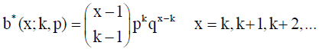 |  | 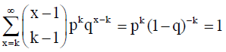 |  |  |  | 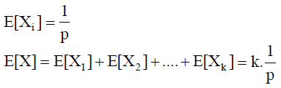
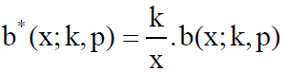
 |  |  |  |  |  | NEGATIVE BINOMIAL VARIANCE
 |  |  |  |  |  | 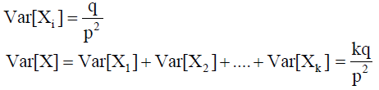
HYPERGEOMETRIC DISTRIBUTION |  |  |  |  | HYPERGEOMETRIC EXPECTED VALUE
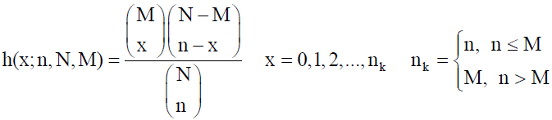 |  |  | 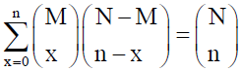 |  | 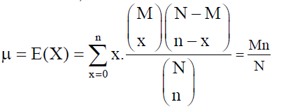 |  |  |  | 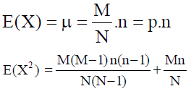  
 |  |  | 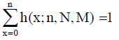
 |  |  |  |  | HYPERGEOMETRIC BINOMIAL VARIANCE
 |  |  |  |  | 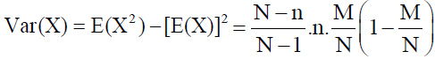 |  |  |  | 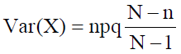

MULTIVARIATE HYPERGEOMETRIC DISTRIBUTION
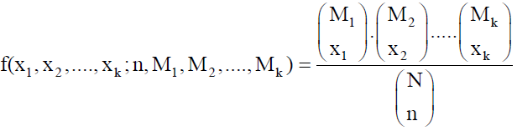 |  |  | 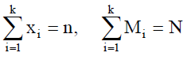 |  | 
POISSION DISTRIBUTION |  |  |  | POISSION EXPECTED VALUE
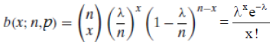 |  | 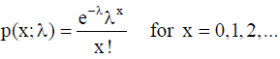 |  | 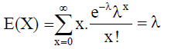 |  | 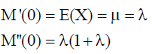
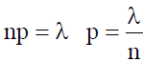 | 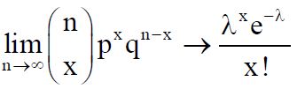 | 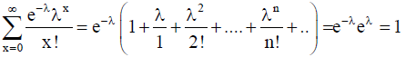
POISSION MOMENT GENERATING FUNCTION |  |  |  | POISSION VARIANCE
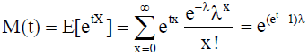 |  |  |  | 